

**ROKYCANY FLOOD PROTECTION**

ADAM BABULJAK, MARIE HOFMANN, ARTHUR GUILLIOT - LE GOFF

COURSE: SPATIAL PLANNING IN FLOOD PROTECTION

LJUBLJANA, 2021/2022

# TABLE OF CONTENTS

TABLE OF CONTENTS 2

1. INTRODUCTION 4

2. LOCATION DESCRIPTION 5

2.1. KLABAVA RIVER 5

2.2. ROKYCANY 7

3. FLOOD HAZARD IDENTIFICATION 8

4. FLOOD PROTECTION IN SPATIAL PLANNING 11

5. FLOOD EVENTS IN THE PAST 14

6. INPUT DATA FOR FLOOD PROTECTION 15

6.1. HYDROLOGICAL CONDITIONS 15

6.2. OWNERSHIP OF LAND NEAR THE CHANNEL 17

6.3. STAKEHOLDERS 18

6.3.1. IN ROKYCANY 18

6.3.2. IN THE KLABAVA RIVER BASIN 18

6.4. OTHER 19

7. FLOOD PROTECTION MEASURES 20

7.1. CURRENTLY IMPLEMENTED 20

7.1.1. ROKYCANY TECHNICAL FP 20

7.2. PLANNED 21

7.2.1. STRENGHTENING CURRENT ROKYCANY FP 21

7.2.2. ROKYCANY NATURE-BASED FP 23

7.2.3. AMERIKA DRY RETENTION AREA 24

7.2.4. BRDY RETENTION CAPACITY INCREASE 26

8. SWOT ANALYSIS 27

9. MCDM ANALYSIS 28

10. CONCLUSION 29

REFERENCES 30

# INTRODUCTION

The seminar deals with the solution of flood protection of the town of Rokycany and its surroundings. This area and especially the district town with a population of approximately 15 000, is at risk of flooding due to the Klabava River flowing from the nearby Brdy Mountains. The Klabava River reacts very quickly to precipitation in the basin, its level rises the fastest of all rivers in the Pilsen region and thus poses a significant flood risk. Because of this and also an inadequate flood protection, this area has been identified as vulnerable to flooding on multiple occasions. A flood in 2002, which caused considerable damage to the town, was showing the Problematic. An increase in the capacity of the channel and protection of the surrounding buildings has been under discussion.

However, the original project was only intended to strengthen the existing visually unattractive and ecologically dysfunctional modifications of the channel. Nevertheless, the active residents of Rokycany, eager to have a nature-friendly, ecologically functional and recreationally attractive flood protection, put so much pressure on the city administration that the original plan was abandoned and now a way is being sought to effectively revitalise the Klabava channel in Rokycany.

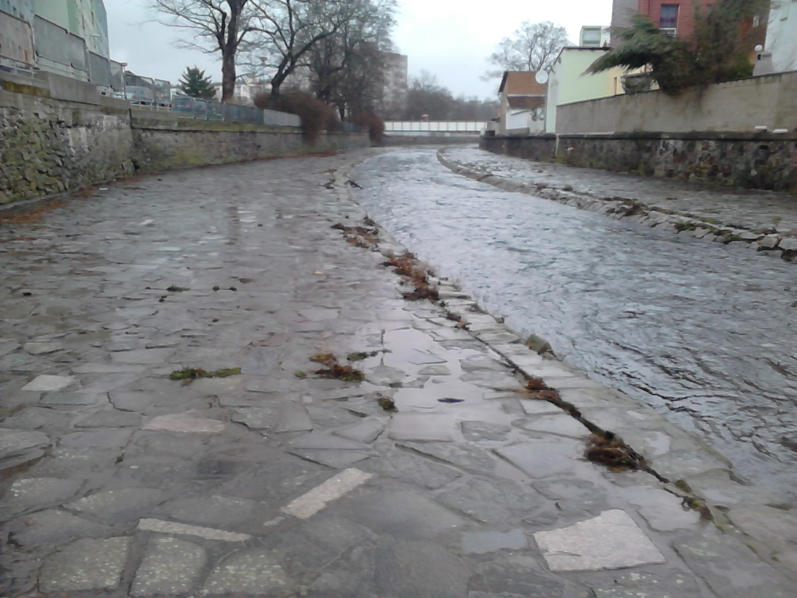This seminar describes the area of interest, its conditions in regards to hydrology, spatial planning, interested stakeholders and more. It furthermore provides detailed information on current flood protection measures and alternatives that are being planned to reduce the flood risk of the area and uses SWOT and MCDM analysis to determine the best solution.

Figure 1 – Current flood protection measures in Rokycany  
Available from: Author’s photography

# LOCATION DESCRIPTION

## KLABAVA RIVER

The Klabava River is located in the Pilsen Region. It is a fourth-order stream and a right-side tributary of the Berounka River. The length of the Klabava is 51.2 km and its catchment area is 373 km² (1).

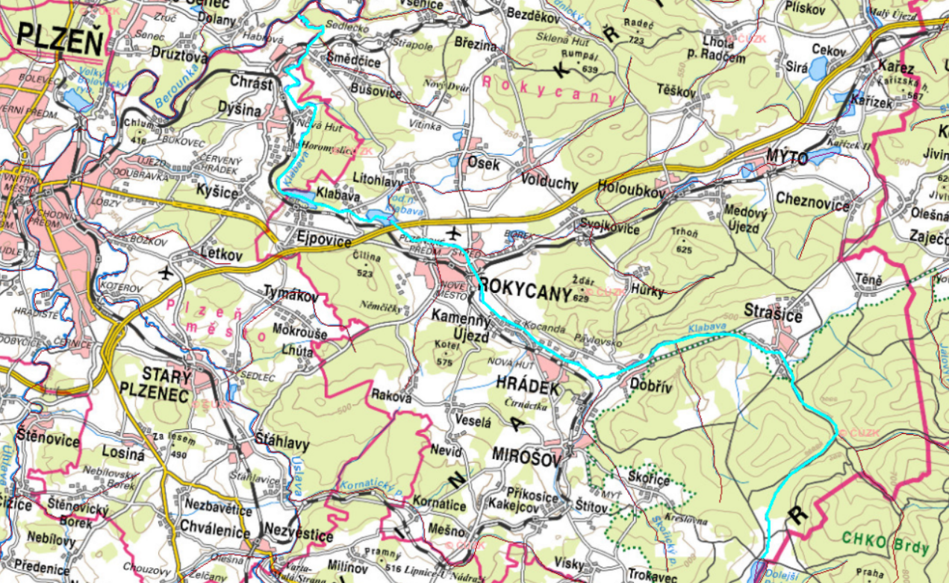The Klabava rises in the Pilsen Region, in the Brdy forests southeast of the village of Teslíny at an altitude of 678 m above sea level, under the name Padrťský potok. On its upper reaches it flows through the Padrťské ponds, the Brdy Protected Landscape Area and the village of Strašice, where the river has a modified channel. Below Strašice, the Klabava River continues through wooded areas to the village of Dobřív. There the river leaves the wooded valley and continues through a wide agricultural floodplain to the town of Hrádek. There, the channel is again modified, straightened and has a large capacity. In Hrádek, the Klabava flows through the industrial area of the ironworks. The municipality of Hrádek then transforms smoothly into the municipality of Kamenný Újezd, where the channel is again modified. Between Kamenný Újezd and Rokycany, the channel is wider, has a natural character and plenty of room for spilling in the surrounding agricultural area. Further on, the river flows through the urban development of the district town of Rokycany, this section is dealt with in detail in the following chapters. Below Rokycany, the river flows through the Klabava dam built in 1957. The dam has a 15-metre high spillway and was built to protect the newly established iron ore quarry near Ejpovice from floods. After a few years, mining was stopped due to the low percentage of iron in the ore. Thus, the Klabava dam lost its original significance and today serves to ensure minimum flow rate, to provide recreation, fishing and flood mitigation. The quarry at Ejpovice was flooded after its closure, creating a flow-through lake through which the Klabava flows below the dam. Above the inlet to the lake, the river overcomes a ten-metre gradient for a short stretch. The original solution in the form of a concrete slipway could not withstand the onslaught of the 2002 floods; today, the height difference is overcome by means of boulder chutes. In the last ten kilometres, the river cuts deeply into the shale massif, flows through Chrást and heads in a natural channel towards the Berounka River, into which it flows at 286 metres above sea level. The most important 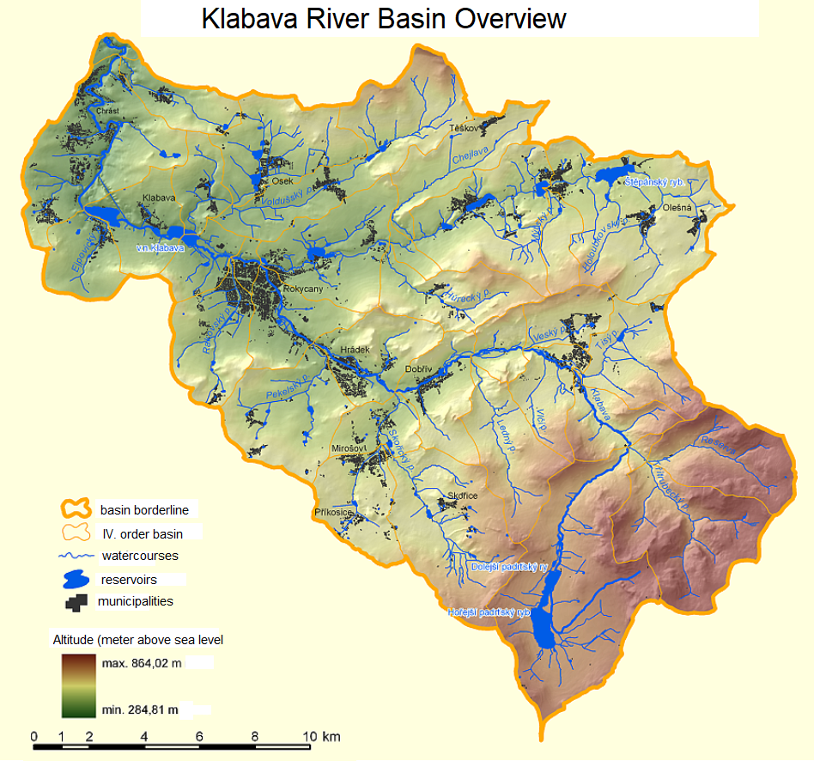tributaries are Skořický potok and Holoubkovský potok brooks (2) (3) (4).

Figure 2 – Geographical location of Klabava River  
Available from: Created in ArcGIS software using the Base Map of the Czech Republic 1:10 000 and the DIBAVOD database

Figure 3 – Klabava River Basin Overview  
Available from: http://www.dibavod.cz/download.php?id_souboru=2312

## ROKYCANY

## In Rokycany, the Klabava first has a natural character. The riverbed is fortified with embankment walls in several places. Below the weir on the river kilometer 21,043 the technical modification of the channel begins. At first, the channel cross-section has trapezoidal shape with a low-capacity cunette in the middle. The surroundings in this area offer sufficient space on both banks for possible channel widening. Above the bridge in Pražská Street, the channel cross-section shape changes into a rectangle cross-section with the low-capacity cunette in the middle, and for the most part there is room to widen the channel in the following passage on at least one of the banks, but there is also a short passage where the channel is constricted by the surrounding built-up area. The most problematic profile is the low-capacity bridge in Soukenická Street, which rises the water level in case of high flows and contributes to flooding of the urban development. Above the confluence of the Klabava River with the Holoubkovský potok brook, the technical modification of the channel ends and the channel regains its natural character. The location of the confluence is again problematic in terms of flooding (as it shows in following chapter). Below the confluence, the Klabava River flows under the Rokycanská stráň nature reserve and often floods the area where many cottages stand on the right bank. The Klabava then leaves Rokycany and flows into the Klabava reservoir few kilometres below it.

Figure 4 – Trapezoidal channel shape  
Author’s photography

Figure 6 –The Low-capacity bridge in Soukenická Street  
Author’s photography

Figure 5 – Rectangular channel shape  
Author’s photography

# FLOOD HAZARD IDENTIFICATION

The flood hazard of Rokycany can be identified analysing multiple different data.

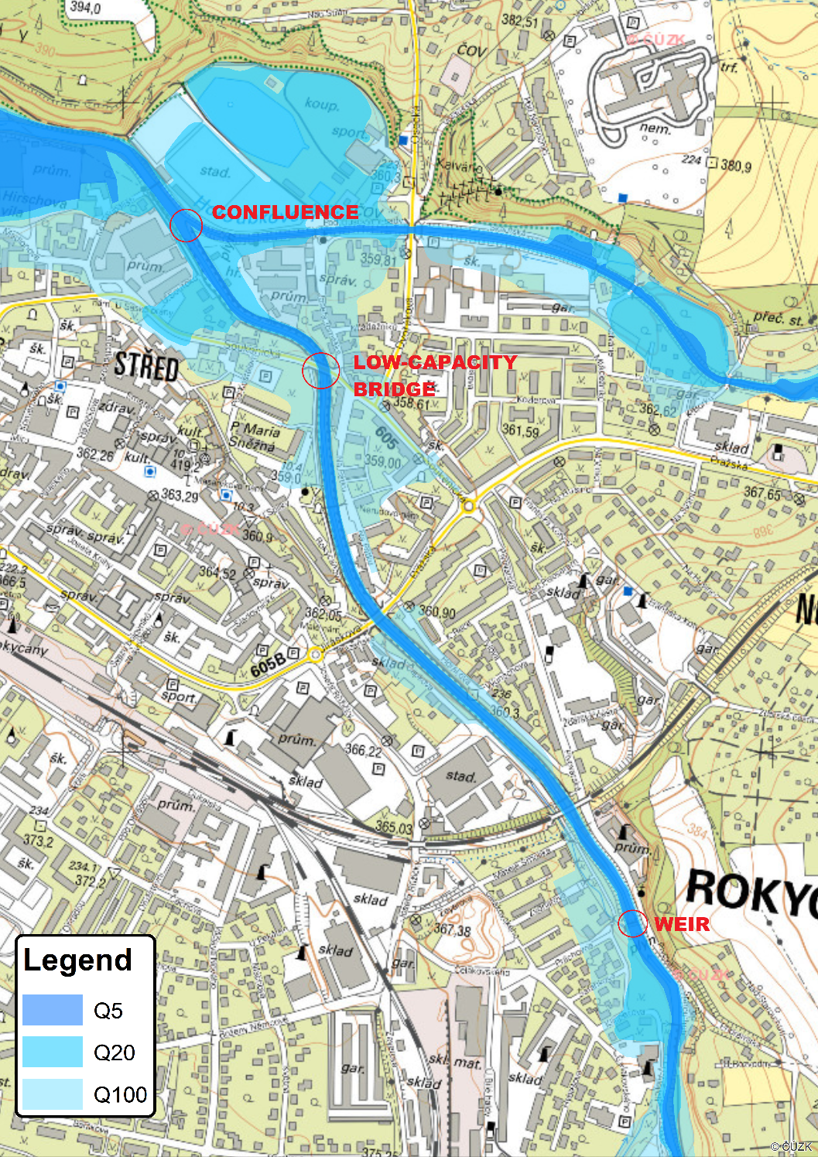First of all, the flood zones show, that arge areas of residential development are at risk of flooding with a return period of 100 years. This concerns mainly the part of the town near the confluence of the Klabava and Holoubkovský potok brook and in the vicinity of the problematic bridge in Soukenická Street. Part of the built-up area is also at risk in the event of a flood with a return period of 20 years. Another problematic reach is the section above the weir at km 21.043, where the buildings on the left bank are threatened by flooding. The aforementioned site with cottages on the right bank of the Klabava below the Rokycanská stráň nature reserve is even threatened by floods with a recurrence period of only 5 years. This site cannot be sufficiently protected by subtle nature-based measures.

Figure 7 – Flooding Zones in Rokycany  
Created in ArcGIS using free DIBAVOD and ČÚZK database

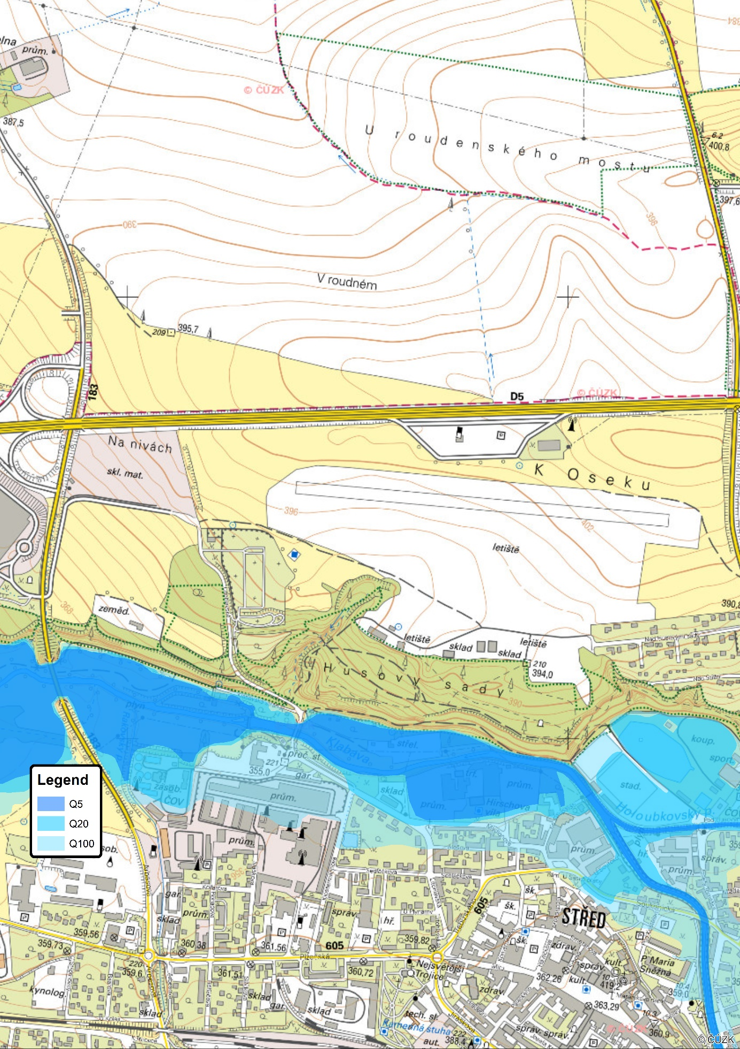The flood risk is also evident from the analysis *Determination of the harmless flow on the Klabava River*, which was carried out in 2014 by Doc. Ing. Aleš Havlík, CSc. (5).

Figure 8 – Flooding zones in flood-prone area near Rokycanská stráň nature reserve  
Created in ArcGIS using free DIBAVOD and ČÚZK database

In this analysis, the harmless flow was determined for many profiles along the entire length of the river, nine of which are in the territory of Rokycany. The results are presented in the following table. For a proper understanding it is necessary to know the hydrological data, which are presented in Chapter 6.1 (5).

The analysis shows that the critical points are the vicinity of the profile of river km 21.129 (a small area around Klicperova Street) and, in particular, the section above the road bridge on Soukenická Street (profiles river km 20.605 to 20.203) and below the outlet of Holoubkovský potok brook (river km 19.203) (5).

|  |  |  |
| --- | --- | --- |
| Stationing | Harmless flow | Description |
| [river km] | [m3.s-1] |
| 21.817 | 190 | Rokycany urban area |
| 21.626 | 190 | Rokycany urban area |
| 21.425 | 140 | Rokycany urban area |
| 21.129 | 80 | Rokycany urban area |
| **20.605** | **100** | **Critical profile in Rokycany** |
| **20.203** | **105** | **Critical profile in Rokycany** |
| 19.748 | 195 | Rokycany urban area |
| 19.458 | 50 | Rokycany urban area |
| **19.203** | **< 40** | **Critical profile in Rokycany** |

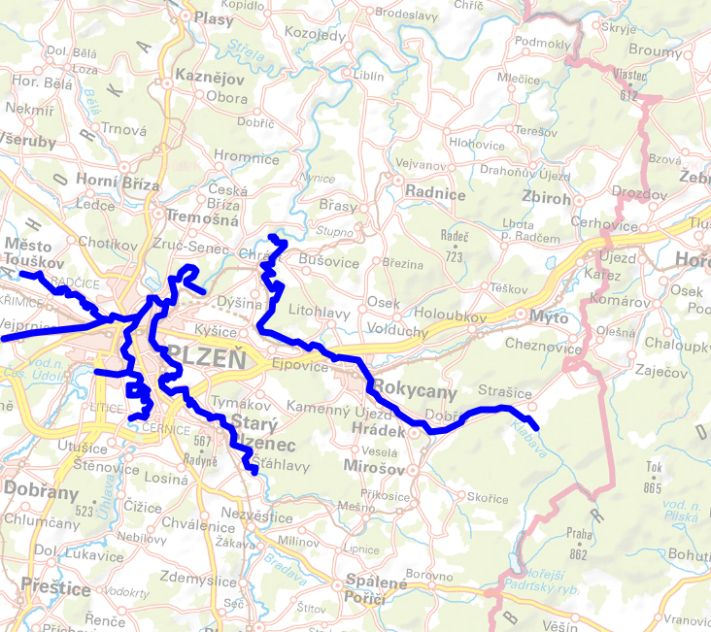The flood risk posed by the river is also evident from many other different sources. According to the *Central Data Warehouse for Flood Hazard and Flood Risk Maps*, surroundings of the Klabava River in the section from Strašice to its confluence with Berounka river are assessed as an area with significant flood risk. *The Strategy for Protection against the Negative Effects of Floods and Erosion Phenomena by Measures Close to Nature in the Czech Republic*, which, among other things, determines the level of flood risk of Czech rivers, classifies the sub-basin of the Klabava River from the tributary of the Skořický potok brook to its confluence with Berounka River as category A - an area with a high level of flood and erosion risk. *The plan of the Berounka sub-basin* also assesses the sections at risk of flooding, one of the twenty-two sections with significant or even unacceptable flood risks is the section of the Klabava River from river km 35.3 to the confluence with Berounka River (6) (7) (8).

Figure 9 – Areas with potentially significant flood risk according to the Central Data Warehouse  
Available from: http://cds.chmi.cz/?lang=cs&presenter=CDSMap

# FLOOD PROTECTION IN SPATIAL PLANNING

Spatial planning in the Czech Republic is carried out only at the level of individual municipalities. Each municipality has its own spatial plan, but no regional or national spatial plans are created. The spatial plan of the town of Rokycany was made in 2018. As far as flood protection is concerned, it is based on the original project of increased Klabava channel capacity, which is a problem in itself, as discussed in the following chapters. The original project addresses the flood protection of the town by strengthening the existing technical modification of the channel and does not implement the surrounding area. The Rokycany spatial plan thus follows this original plan and only dedicates the existing area of the channel to flood protection. The surrounding land is mostly included in the category of *urban green space - park*. In the drawing of the technical infrastructure concept, the area of the existing Klabava channel is categorised as *a specific area - flood protection measures in urban area* (9).

Figure 10 – Rokycany Spatial Plan – Main Drawing  
Available from: https://www.rokycany.cz/uzemni-plan-mesta/ds-6937

The drawing of public utility structures, measures and remediation then includes the existing Klabava riverbed in the category of *Public utility structures and public utility measures*, however, the nearby surroundings of the channel, which could be used for flood protection measures, are not included in this category - which is again based on the original project of the increasing the Klabava channel capacity (9).

In the text part of the plan, it states that it pays great attention to urban greenery, among others. It proposes to add greenery and to continuously connect the banks of the Klabava River and Holoubkovský potok and Rakovský potok brooks with pedestrian and cycling paths and to propose the principle of revitalisation and flood protection of the Klabava River, Holoubkovský potok and Rakovský potok brooks, incorporate the established floodplains and flood protection measures, examine the possibility of using part of the area around the watercourses for leisure and recreational activities of the inhabitant – e.g. parks and recreational greenery, natural playgrounds and sports grounds, walking paths, cycling and roller-skating trails, etc.. According to the text part, the spatial plan proposes to keep undevelopable places near 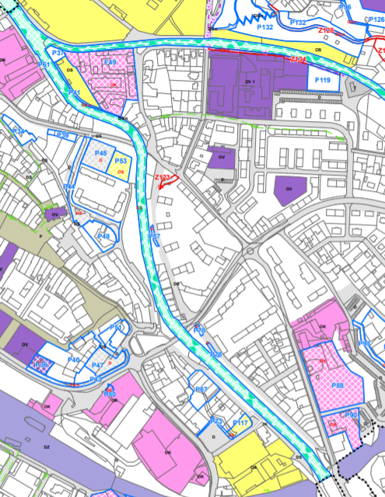watercourses to ensure their accessibility, also to ensure access to future flood protection measures, and to minimize all possible impacts that could negatively affect the runoff conditions in the area (9).

At the same time, the spatial plan states that the Klabava and Holoubkovský potok brook in the urban area will be solved in the original - technical way by reconstruction of the existing channel, which corresponds to the entire main - drawing part (9).

Figure 11 – Rokycany Spatial Plan, Urban Concept Drawing  
Available from: https://www.rokycany.cz/uzemni-plan-mesta/ds-6937

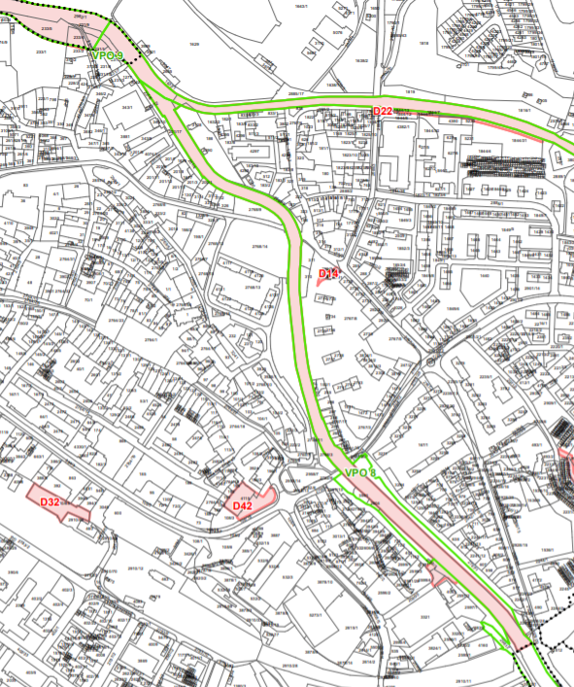The zoning plan, however, mentions that the design of the flood protection of the town may still change, so it is clearly visible that the concept of flood protection of Rokycany is not fixed and the spatial plan does not bring anything new in this respect (9).

Figure 12 – Rokycany Spatial Plan - Drawing of Public Untility Structures, Measures and Remediation  
https://www.rokycany.cz/uzemni-plan-mesta/ds-6937

As stated earlier, there are no spatial plans on regional or national level in the Czech Republic, however there are multiple analyses, plans and concepts when it comes to flood protection on greater than municipal level.

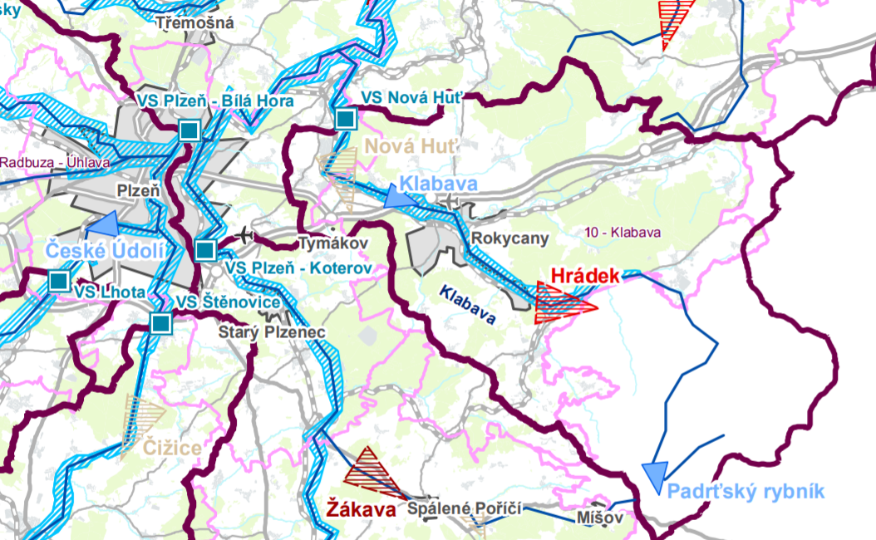On regional level, we can find the Assessment of the Retention Capacity of the Pilsen Region, which analyses whole region and tries to find space for water accumulation and flood mitigation. In the Klabava catchment, there is one such area - spatial reserve for a surface water storage site as a flood mitigation measure in the municipality of Hrádek u Rokycan, which is also incorporated in the Hrádek u Rokycan Spatial Plan (10).

Figure 13 - Assessment of the Retention Capacity of the Pilsen Region  
Available from: https://geoportal.plzensky-kraj.cz/gs/uzemni-plany-a-dalsi-nastroje-uzemniho-planovani/

Planning at the river basin level in this area is provided by the Berounka Sub-basin Plan. This plan indentifies the flood risk associated with the Klabava River and choose the following general measures to mitigate flood risk: Acquisition/amendment of the spatial plan (definition of undevelopable areas and areas with limited use), Use of flood risk map outputs (flood risk, areas at risk) as a limit in spatial planning and management, Measures to reduce the adverse effects of floods on buildings, public networks, etc, Individual FPs of property owners, Measures to improve reporting and forecasting services, Creation/updating of flood plans for subdivisions and properties. However when it comes to List of proposed flood protection measures, the only one here is the original increased capacity of Klabava channel project which was abandoned as this Berounka Sub-basin Plan was made in 2014 (7).

The planning instruments at the national level in the Czech Republic (Flood Protection Strategy for the territory of the Czech Republic, Concept for solving the problem of flood protection in the Czech Republic with the use of technical and nature-based measures) represent only a list of general principles and not specific solutions. Moreover, they do not go into detail, so there are no recommendations or plans for the Klabava River basin on the national level of planning.

# FLOOD EVENTS IN THE PAST

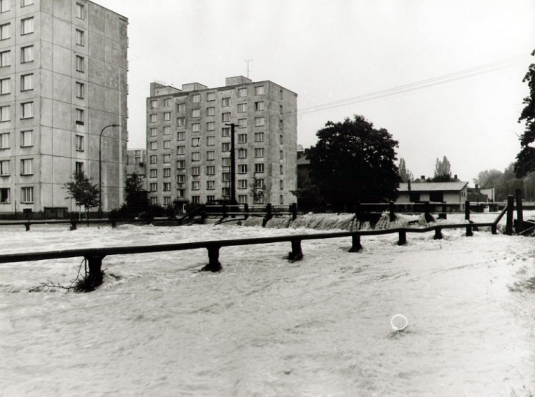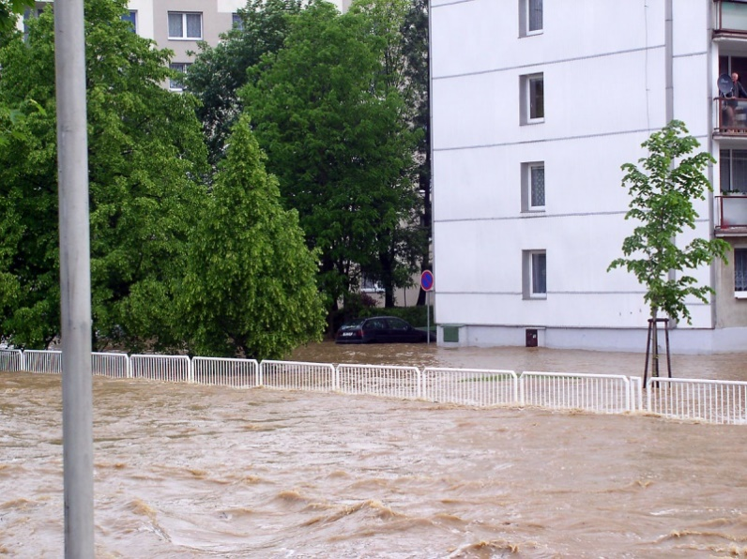Floods are a relatively frequent phenomenon in the history of Rokycany. The first historically recorded flood in the town occurred in the spring of 1598. Other floods, of greater or lesser extent, took place in 1713, 1750 (15 June), 1752, 1770 (17 April), 1786, 1824, 1872, 1890, 1893, 1895, 1909, 1922 (13 June), and 1890 (13 June). 9.), 1930, 1949, 1965 (17. - 18. 7.), 1978 (6. - 9. 5.), 1980 (21. - 22. 7.), 1981, 2002 (6. - 7. 8., 11. - 13. 8.) a 2006 (28. 5.). In 2002, a serious situation occurred especially after continuous rain on the night of 12-13 August. In the morning hours the maximum flow in Rokycany was approximately 325 m3/s. The level of the 100-year flow was significantly exceeded and large coastal parts of the town were flooded. The floods of August 2002 were the most devastating floods in the modern history of the Czech Republic and led to major investments in flood protection. It was after these floods that intentions to solve the flood protection of Rokycany began, but almost twenty years after the flood, even the basic concept has still not been established. The last significant floods in Rokycany occurred in June 2013 (11).

Figure 14 – Floods in 1980; Available from: http://rokypedie.rokycanstipatrioti.cz/index.php?title=Povodn%C4%9B

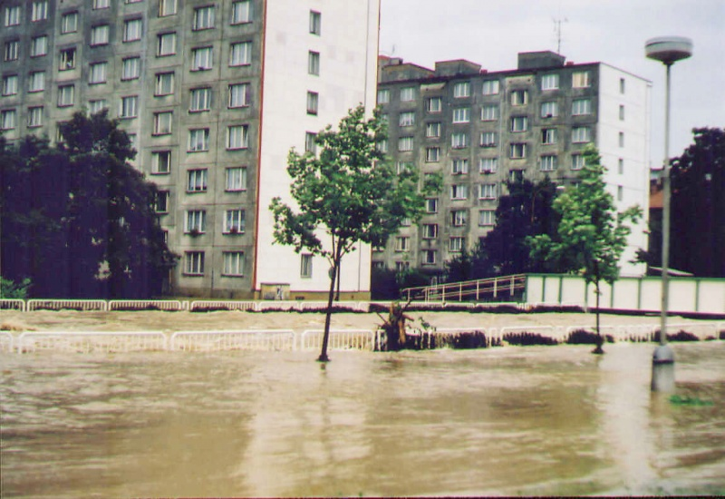

Figure 15 – Floods in 2002; Available from: http://rokypedie.rokycanstipatrioti.cz/index.php?title=Povodn%C4%9B

Figure 16 – Floods in 2006; Available from: http://rokypedie.rokycanstipatrioti.cz/index.php?title=Povodn%C4%9B

# INPUT DATA FOR FLOOD PROTECTION

## HYDROLOGICAL CONDITIONS

## The Klabava River catchment area has relatively high precipitation values in the context of the Czech Republic, both in the long-term average and in short-term precipitation events, because a large part of the catchment area is located in the precipitation-rich northwestern part of the Brdy Mountains. This is evident both from the data of the Czech Hydrometeorological Institute and from the data of the Rain application operated by the Czech Technical University in Prague, which provides rainfall totals for the 4th order basins for six-hourly rainfall with different recurrence times (12) (13):

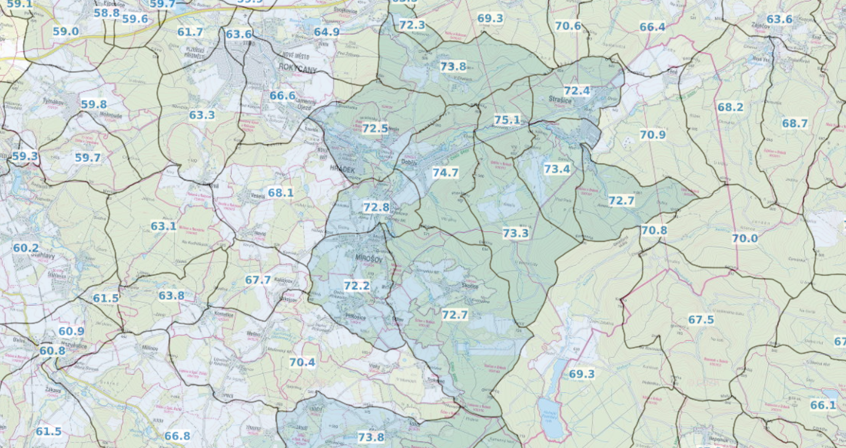

Figure 17 – Mean Rainfall in Czech Republic (1961-2000)  
Available from: https://www.in-pocasi.cz/archiv/klima.php

*Figure 18 - Rainfall totals of 6 hours with a return period of 100 years in mm (CTU application Rain)  
Available from: https://rain.fsv.cvut.cz/webapp/gisquick/*

These 6-hour rainfall totals (accompanied by their time-series’ with different probabilities) can be used as input data for hydrological models, when not only specific design flow rate values is necessary, but also a time-series of flow-rate is needed (13).

However, when only a design flow rate is needed for the flood protection measures design purposes, the following table QN with N-year return period which was produced by SWECO Hydroprojekt company in 2015 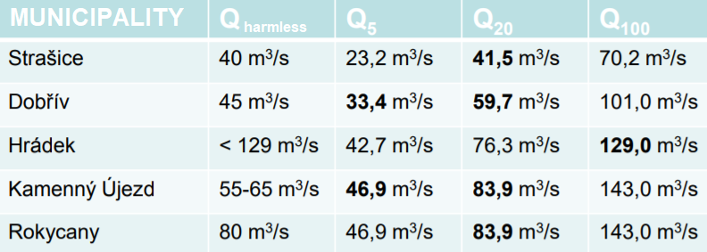can be used (14):

Figure 19 – QN table according to SWECO Hydroprojekt a.s. (2015)  
Available from: http://www.mestohradek-ro.cz/assets/File.ashx?id_org=4730&id_dokumenty=55422

According to the SWECO Hydroprojekt Final report (a part of original technical measures project carried out in 2014), QN values above and below the confluence of Klabava River and Houloubkovský potok brook is as follows (15):

|  |  |  |  |
| --- | --- | --- | --- |
| Profile | ***Q5*** | ***Q20*** | ***Q100*** |
| [m3.s-1] | [m3.s-1] | [m3.s-1] |
| Klabava above the confluence | 46.9 | 81.3 | 143 |
| Klabava below the confluence | 55.3 | 107.0 | 195 |

For slightly more detailed hydrological data for the technically modified channel in Rokycany urban area, the following data from Operational Profile Record Sheet – Na Pátku, Rokycany can be used. The operational profile is located in the middle of technically modified channel, above the confluence of Klabava River and Holoubkovský potok (16).



Figure 20 – QN table according to Operational Profile Record Sheet – Na Pátku (16)  
Available from: https://hydro.chmi.cz/hpps/evlist.php?seq=20045969

## OWNERSHIP OF LAND NEAR THE CHANNEL

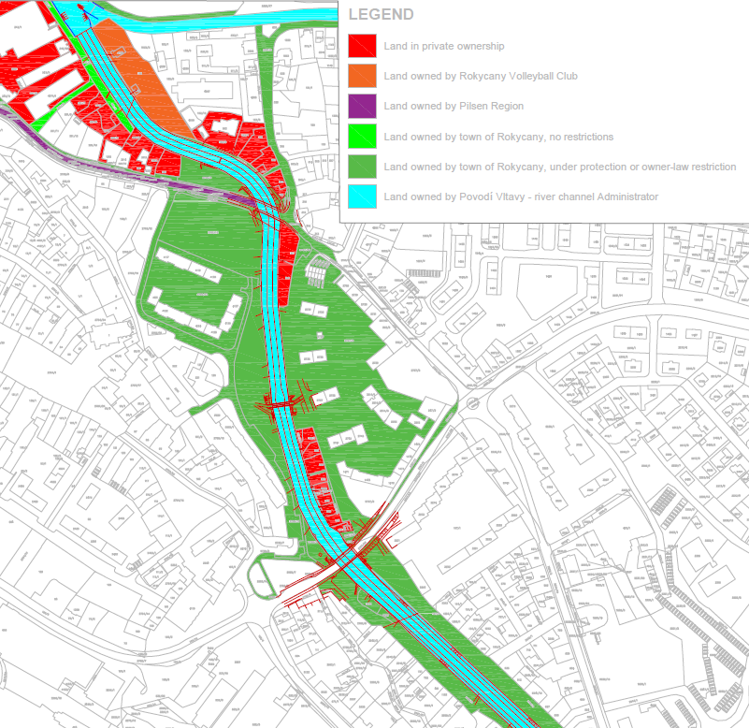In the Rokycany urban area, there is enough space along most of the technically modified channel to widen the channel and to create a high-capacity and more nature-based channel as a flood protection measure. That said, the property relations in the vicinity of the channel play an absolutely crucial role in the design of flood protection measures. Their analysis shows that most of the land belongs to the town of Rokycany, which would certainly allow the channel to be extended onto these lands. Although most of these plots are located in a conservation area due to their location in the historical centre of Rokycany, this should not be a major problem given the expected nature of the works to be carried out. The Povodí Vltavy s.p. company, which is the administrator of the state-owned land on which the existing riverbed lies, would certainly permit any flood protection measures on its land. The problem should not arise even if the land on the road near the bridge on Soukenická Street, which is owned by the Pilsen Region, is affected. In the event of measures affecting the existing sports ground on the so-called 'Ostrůvkek' peninsula by the confluence of Klabava River and Holoubkovský potok brook, it would be necessary to negotiate these measures with the Rokycany Volleyball Club, the owner of the land.

Figure 21 – Ownership of land near the channel in Rokycany urban area  
Analysis based on Czech Land Registry open data

## STAKEHOLDERS

It is important to identify the stakeholders and their interests when it comes to flood protection planning. Stakeholders need to be involved from the very beginning to achieve the best possible final outcome for everyone interested. This is why the following stakeholder description is provided in the input data chapter.

### IN ROKYCANY

1. Rokycany municipal authorities: The projects contracting authority and partial investor. The motivation is to get the flood protection sorted as quickly and as cheaply as possible. This is changing due to the public pressure, so in order to satisfy the public, the municipal authorities are (or at least they claim to be) willing to invest more time, effort and financial resources to create a better solution.
2. Povodí Vltavy s.p. – the watercourse administrator and channel property administrator: The motivation is to secure the appropriate flood protection level to satisfy the standards. This company is also developing in the sense of supporting more nature-based solutions.
3. AOPK ČR, ČSOP – Institutions making sure that the least possible harm is done to the nature.
4. Owners of the nearby properties – Their intentions are to pressure the local authorities into the quickest possible solution to secure the protection of their private property from public funds. They are not willing to give up their land for any nature-friendly solutions or public space development.
5. Kulíšek – The civic movement representing both the general public and the ecologically minded inhabitants. They will fight against any solution that doesn’t support the ecological functions of the river and the public space development. They root for a project that will serve the whole community and increase the general standard of living in the town.

### IN THE KLABAVA RIVER BASIN

In case of implementation of such flood protection measures that would affect area outside of the town of Rokycany (e.g. dry retention area in Brdy Mountains), the following stakeholders (among others and those already mentioned) need to be considered and implemented in flood protection measures decision making processes:

Lesy ČR - companies owning and managing forest land in the Czech Republic

AOPK ČR as CHKO Brdy Administrator – in case of such flood protection measures that would affect Brdy Mountains Protected Landscape Area, AOPK ČR, its administrator plays a major role.

Municipalities in and below the area of interest and their inhabitants

Army of the Czech Republic – The army uses extensive land in the Brdy Mountains for its purposes

Owners of land in the area of interest or below it.

## OTHER

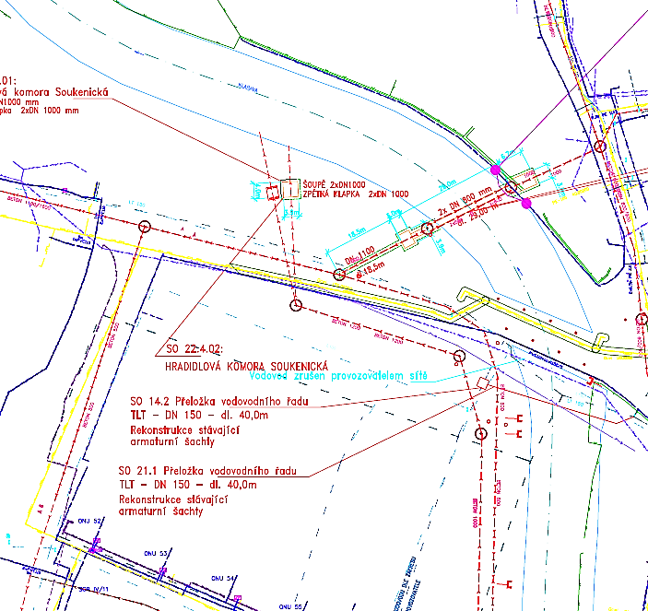A fundamental issue for the feasibility of any intervention in the area around the channel is the utility infrastructure, especially in urban areas, as in the case of Rokycany urban area. A problem may be caused by the main sewer line, which runs along almost the entire stretch of the channel in its immediate vicinity on both banks. However, based on the data available, it is impossible to. The utility infrastructure in the vicinity of the channel is very dense. Thus, widening the channel would certainly involve numerous utility relocations. This is a major problem both in terms of the feasibility of the measure and its financial cost, which requires a more thorough analysis for an objective assessment. For the time being, it is assumed that all utilities can be relocated and thus do not limit the feasibility of the modifications, which was established for the study commissioned by the city, on the grounds that utilities are often out-dated and their replacement is inevitable in the near future (17).

Figure 22 – Unility infrastructure near the bridge in Soukenická Street; extracted from the drawing documentation of the original project (17)

# FLOOD PROTECTION MEASURES

## CURRENTLY IMPLEMENTED

### ROKYCANY TECHNICAL FP

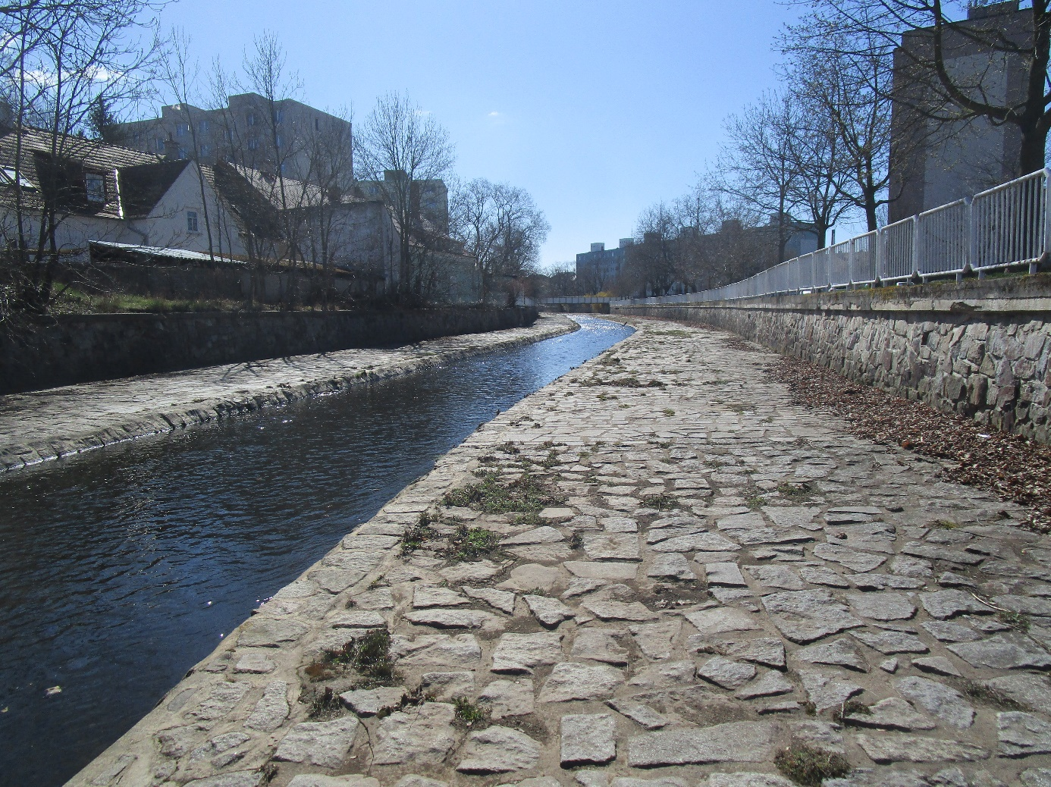As already mentioned, the existing flood protection measures in Rokycany urban area result in a channel which is very visually unattractive and inaccessible to the inhabitants of Rokycany, it offers no possibility for leasure use and its only purpose is flood protection of the urban area. It is a purely pragmatic construction without any ecological value. The channel has a very monotonous character with no diversity in terms of shape or hydraulic characeristics. Most of the time the flow is concentrated in the cunette which, except at the end of the section where the channel structure is damaged, has an unnecessarily large capacity, resulting in insufficient depth to provide an ecological function. Ecological function is however equally unthinkable given the monotony of the channel, hydraulic characteristics and solution of the channel surface, which is made up of stone paving throughout the entire width of the section of interest. Moreover, the flood protection is insufficient and does not meet the requirement to protect the surrounding development from floods with return period of 100 years.

Figure 23 – The current flood protection measures in Rokycany urban area  
Author’s photography

## PLANNED

### STRENGHTENING CURRENT ROKYCANY FP

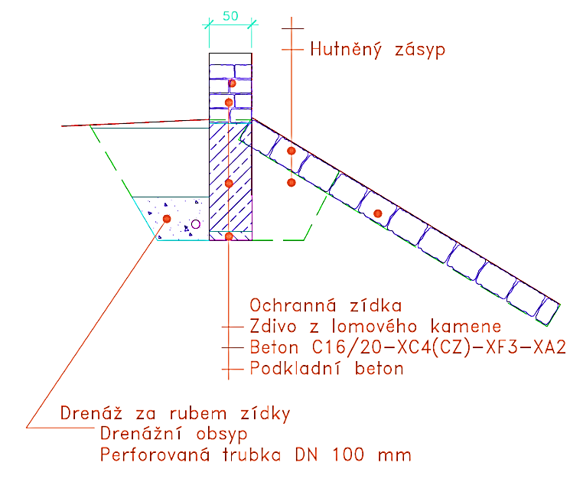The inhabitants of Rokycany became convinced that the flood protection measures in Rokycany are not sufficient during the floods in 2002, when the damage in Rokycany amounted to 1,6 million €. In 2004, the preparation of a project to increase the channel capacity began. The resulting project cost was EUR 20 million without VAT and was submitted to the city in 2014. (18).

The flood protection project consisted in the construction of 100 or 110 mm high protective walls on the edges of the existing channel.. The cross-section of the channel was to be changed only in the lower section of the rectangular channel, where the low-capacity bridge in Soukenická Street is located. Here, ensuring the capacity of the channel for Q100 was solved by excavating the channel by about 1 m. The project also included a major modification of the channel below the confluence with Holoubkovský Brook. Here, a significant excavating of the channel was proposed. The profile was designed with a freely meandering channel. The level of the bottom of the cunette and the adjacent wide berms was to be fundamentally changed compared to the current situation (5) (19). According to the calculations, the implementation of the channel modifications proposed in this project would ensure effective reduction of the flood flow level ensuring protection of the urban development of Rokycany for the design flow of Q100. Therefore, the original project offered a hydraulically functional, relatively simple, easy to implement and technically very efficient solution.

Figure 24 – Protection walls contruction according to the original project; taken from the project drawings (19)

In July 2014, a decision on the placing of the construction was issued. However, at that moment the Kulíšek civic association stepped in and appealed against the placing of the construction. The appeals authority annulled the contested decision and referred it back for reconsideration. This started a dispute in which the Vltava River Basin took one side, arguing that the designer's aim was to choose a solution that would disturb the existing situation as little as possible, which could not be done better under the existing conditions. Moreover, in Rokycany the flood arrival is so fast that the installation of mobile flood barriers cannot be counted on. The protective walls would be made of the same material as the original walls to maintain the current visual perception of the channel. It is therefore in no way about separating the stream from the urban environment using with concrete walls or cutting the river off as an architectural and biological feature from the city. Other supporters of the original project are the owners of land near the river. They hope for the construction of flood protection measures as soon as possible, which would protect their private property from public funds (20).

On the other side stood the Kulíšek civic association and a large group of its supporters from among the inhabitants of Rokycany, who were bound together by the wish that public funds should be used to take measures that would be optimal for all the inhabitants of the town, measures that would make the river more accessible, enable its use for recreational purposes and return the channel to a more natural character. They want nature-based flood protection measures using channel widening to reach the required capacity (20).

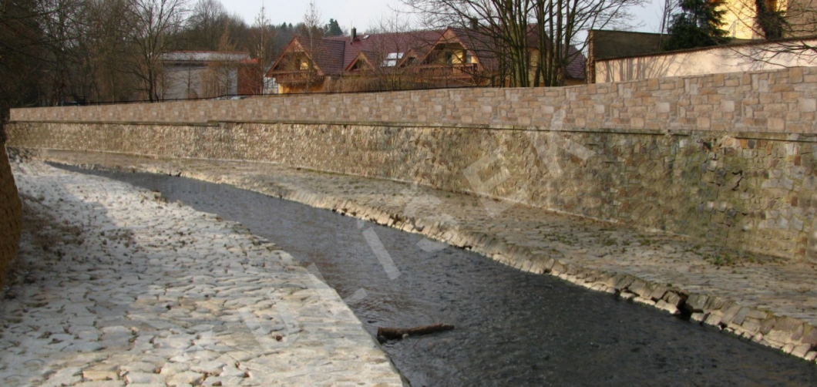 Rokycany ecologists have done very well in promoting the implementation of nature-based measures in the Klabava channel. Through their civic activism, organising events to raise awareness of the issue and creating a petition signed by 800 Rokycany residents, they managed to put pressure on the city administration, which led to the postponement of the flood protection implementation and stopping of the project. The project was then gradually reshaped in an attempt to find the best possible solution for all parties involved. The Vltava River Basin company has tried to negotiate with the city to ensure that the measure proposed by the ecologists are technically feasible and meets what is expected of it. (18)

Figure 25 – Visualisation of channel modification by protective walls  
Available from: https://www.vlada.cz/assets/ppov/udrzitelny-rozvoj/vybory-rvur/Klabava.pdf

### ROKYCANY NATURE-BASED FP

In June 2019, the Rokycany City Council approved the solution of flood protection measures in the town of Rokycany - in a nature-friendly way and on the entire territory of the city. The new project will be significantly more financially demanding than the originally planned strengthening of technical flood protection, but it will ensure the protection of the entire town, create an attractive space for visitors and be more nature-friendly(21)*.*

The first step in this direction – a nature-based flood protection measures feasibility study was already prepared in 2021 and is now at the stage of negotiating. The study should be followed by the actual project. However, the question whether such a costly and complex project will ever be implemented remains.

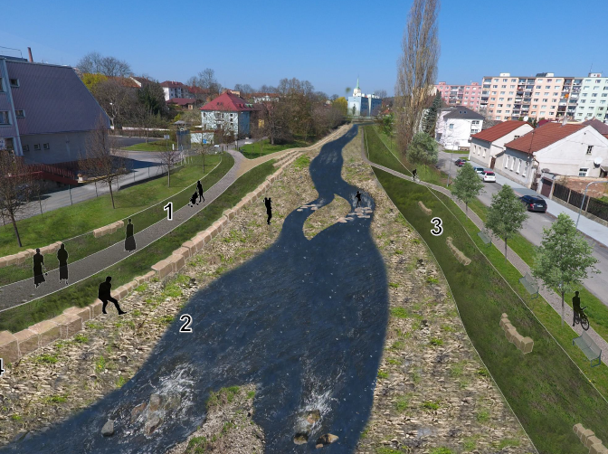The study presents a flood protection concept that uses nature-friendly measures. Instead of technical elements, the emphasis is on widening the channel to the sides, making the channel accessible to the residents, implementing walking and cycling paths and creating an ecologically functional nature-friendly cycletrack. In addition, the study also addresses the Holoubkovský potok brook and Rakovský potok brook channels. It all looks good on paper, but the latest working version of the study does not yet provide any indicative costs for the investment. These are likely to far exceed the costs associated with a simpler, more technical solution and quite possibly the financial possibilities of the town. Thus, the likelihood of such flood protection measures implementation remains unclear (22).

Figure 26 – Nature-based flood protection measures visualisation according to the feasibility study  
Available from: https://m.rokycany.cz/assets/File.ashx?id_org=14069&id_dokumenty=899993

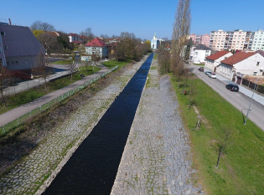

### AMERIKA DRY RETENTION AREA

Figure 27 – Overview of nature-based flood protection measures of one Klabava channel section according to the feasibility study. Available from: https://www.rokycany.cz/assets/File.ashx?id_org=14069&id_dokumenty=899996

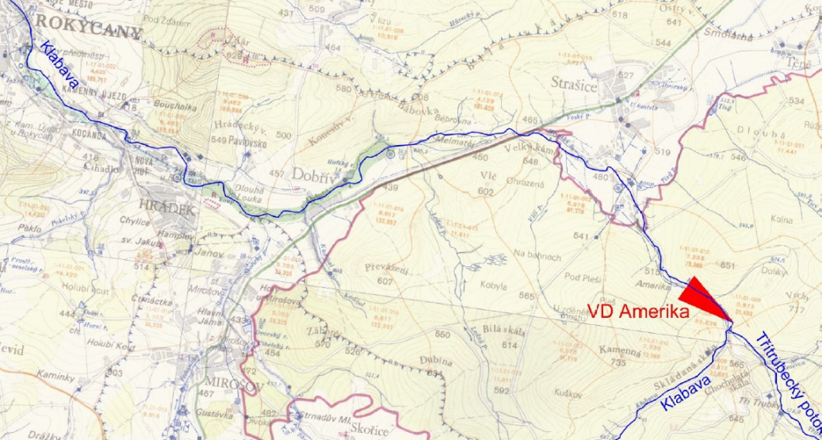Another possible option on how to ensure sufficient flood protection of not only the town of Rokycany, but also other towns and villages located on the Klabava river banks (Kamenný Újezd, Hrádek, Dobřív and Strašice with combined population of 7250) is construction of a dry retention area in the Brdy Mountains, where the major part of a flood wave comes from. This dry retention area could retain a large volume of water in case of heavy rainfall and mitigate the flooding in such way, that the already existing flood protection measures in the villages and towns located below the dry retention area would provide sufficient flood protection for the river channel surrounding development. Therefore, The Amerika dry retention area was planned in the last decade (23).

Figure 28 – Location of designed Amerika dry retention area  
Available from: https://www.pvl.cz/vodohospodarske-informace/zamer-vd-amerika

The feasibility study was carried out in 2015. The proposed dam of dry retention area was supposed to be 21,85 m high and the area flooded in case of flood with return period of 1000 years was 29 ha. The study shows that proposed dry retention area would effectively decrease Q100 (66,7 m3/s) to Qharmless (19,4 m3/s). Investment costs were estimated at EUR 21,84 million without VAT and the reduction of capitalised risk was evaluated at EUR 24,76 million, which makes the construction reasonable from economical point of view. It would also ensure flood protection of 1340 people. However, the major issue comes with the location of Amerika dry retention area. It was supposed to be located in Brdy Protected Landscape Area in a very valuable area both ecologically and landscape-wise. Construction of the dry retention area would mean permanent deforestation of the area of 29 ha, which would pose a serious interference with the landscape character. It would pose a threat to the population of stone crayfish which is endangered specie in Czech Republic and lives in this location. These were the reasons which led the major of Strašice – the municipality in territory of which is the area of interest located – to rise against the Amerika dry retention area intent. This happened in 2016 and stopped the process of dry retention area implementation. Since then, no progress has been made and according to the major of Strašice, the chances of Amerika dry retention area construction are close to nothing (23).

Figure 29 – Amerika dry retention area visualisation  
Available from: https://www.pvl.cz/vodohospodarske-informace/zamer-vd-amerika

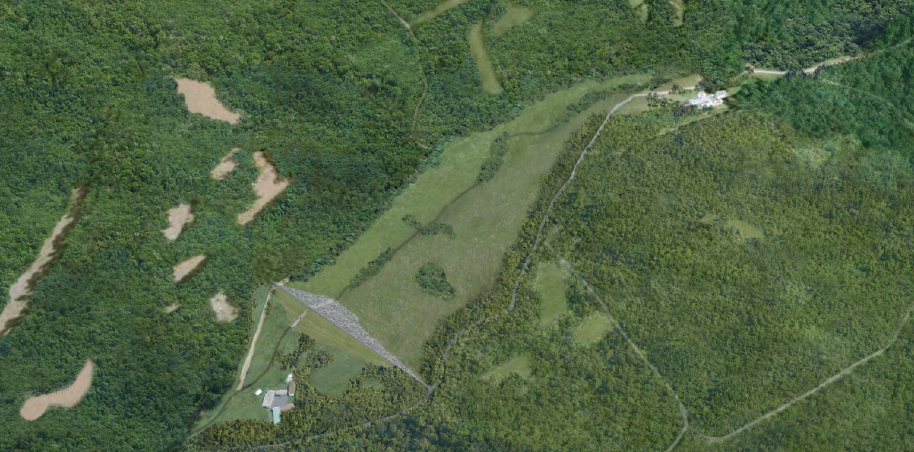In 2020, an idea of constructing similar dry retention area on Ledecký potok brook (brook in the valley next to the Klabava river valley) emerged as it seems like the idea of solving flood protection of the Klabava catchment via dry retention area is an option under consideration by the watercourse administrator (Povodí Vltavy s.p.) (24).

### BRDY RETENTION CAPACITY INCREASE

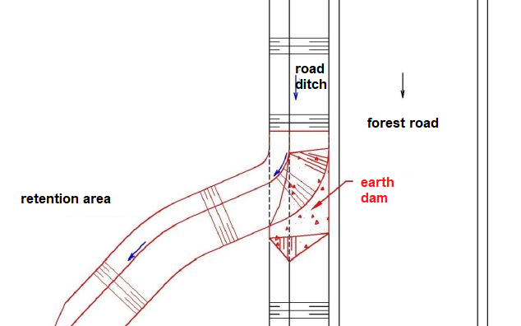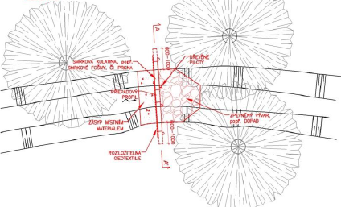In 2017, the design office SWECO Hydroprojekt a.s. prepared a study to increase the retention capacity of the source area of the Brdy Protected Landscape Area in the Klabava basin. Although it is a predominantly forested area, the meadows around Padrťské rybníky ponds were inappropriately drained in the past. A drainage ditch, sometimes several metres deep, has been created along the road from the dam of Dolejší Padrťský rybník pond to Hořejší Padrťský rybník pond. Melioration has been implemented in the surrounding forests, which significantly accelerates runoff and reduces water retention in the event of rainfall. Inappropriate management practices are practiced in the forests, and the road network and associated drainage ditches contribute to rapid runoff from the catchment. These are the problems addressed in this study. A set of measures was proposed to help reduce runoff, including the removal of the Padrťské rybníky ponds bypass channel (greater transformation of flows through the reservoirs), nature-based measures on watercourses, measures on drainage ditches, measures on the road network (increasing the time of concentration in the catchments) and changes in forest management practices. The effectiveness of each measure and their combination was evaluated using the HEC-HMS model. The flow with a 100-year return period of Q100 would be reduced by more than 25% from 68,7 m3/s in the catchment area closure profile to 51,3 m3/s with the application of all proposed measures. For flows with shorter recurrence times, the effectiveness of the proposed measures is then even greater (for Q5 the effectiveness is 36%) (25).

Figure 30 – One of proposed measures – damming of the draining ditch Available from: http://www.cski-cr.cz/wp-content/uploads/2017/11/10_Stehlik.pdf

Then in 2020 the first measure proposed by this study was implemented - Modification of the bypass ditch and creation of pools to slow down the runoff from the basin (25) (26).

Obrázek 31 – One o proposed measures – retaining the road ditch runoff  
Available from: http://www.cski-cr.cz/wp-content/uploads/2017/11/10_Stehlik.pdf

# SWOT ANALYSIS

The SWOT analysis is divided into multiple parts. The first one concerns the current riverbed, giving an overview of the situation.

The next SWOT analysis is concerning the spatial planning in the Check republic and the given area.

The following SWOT analysis is giving an overview of the presented solutions.

# MCDM ANALYSIS

The multi-criteria decision-making is another way to compare solutions by reducing the subjectivity in decision making while focusing on a more quantitative approach. For this comparison, certain criteria are identified and each solution is given a score according to these criteria.

For this analysis we decided to take into account four criteria which we consider essential in the decision-making process:

* The ability to retain flooding,
* the costs,
* the integration into the landscape,
* the environmental impact,

In addition to each note we add a weight which will condition the importance of each criteria in relation to the others. We therefore have considered several scenarios varying these weights to take into account several philosophies. In every cases, the most important is the ability to retain flooding, it is why the weight of this criteria are always the greatest. In the first scenario, we consider that the economic aspect is the second most important factor. In second, costs and environmental impact share equal importance. The last scenario focuses on environmental protection. We have always considered that integration into the landscape was the least important criterion in each case.







This variation in weight gives us very different results for the ranking of the different solutions. It is up to the municipality to choose, according to the budgets but also to the will of the citizens. The comparison of these different cases can be brought during a phase of consultation to receive the opinions of the inhabitants on the direction they want to give to the project.

# CONCLUSION

This paper dealt with the flood protection of Rokycany. It gave an overview over the riverbed, first natural, then channelized and restrained by a bridge. Then, floods and damages, caused by the current situation were presented, showing the high damage potential. Moreover, stakeholders were presented to give a background of the feasibility of the measures.

For the channel situation, different solutions where presented. First the strengthening of the current Rokycany Flood Protection by excavating the river channel and heightening the flood protection walls. This measurement would be the fastest and easiest to implement, without bringing any ecological or recreational benefit. Moreover, the possibility of a renaturation of the riverbed while including recreational purposes such as walking and biking trails were considered. Furthermore, the possibility of an American dry retention basin was presented but neglected due to the loss of very valuable habitat. The last measurement shown, is the closing of drainage ditches in the Brdy area, leading to a higher retention of water and therefore lower load peaks in the case of flooding.

To further evaluate the choice of flood protection, a SWAT analysis was done. It has been made clear, how the current situation is neither meeting the need for flood protection, nor the recreational needs of the inhabitants. Then, the presented solutions where evaluated, stating, how the nature-based solution in combination with the use of the Brdy area as retention area is showing the best results for offering recreational space for inhabitants and ecologically valuable habitat. And even if this solution is also favoured by a high share of the inhabitants, the high economic investment may make this solution not feasible.

# REFERENCES

1. **Klabava (řeka). [Online] [Citace: 4. 5 2020.] http://www.wikiwand.com/cs/Klabava_(%C5%99eka).**

**2. Fortinová, Lenka. Řeka Klabava - Česká republika. *infoglobe.* [Online] 19. 8 2010. [Citace: 4. 5 2020.] https://www.infoglobe.cz/reky/evropa/ceska-republika/klabava/#menu.**

**3. VD Klabava. [Online] [Citace: 4. 5 2020.] http://www.pvl.cz/files/download/vodohospodarske-informace/vodni-dila-a-nadrze/klabava.pdf.**

**4. Dokumentace oblastí s významným povodňovým rizikem. *PLÁN DÍLČÍHO POVODÍ BEROUNKY.* [Online] Povodí Vltavy s.p., 1 2016. [Citace: 21. 4 2020.] http://www.pvl.cz/portal/pdp/BE/DOsVPR/1_Text/BER_Rokycany.pdf.**

**5. Havlík, Aleš. Klabava Rokycany, zkapacitnění koryta v ř. km 17,900 - 20,500 studie odtokových poměrů: ZÁVĚREČNÁ ZPRÁVA - ETAPA A. Praha : autor neznámý, 2014.**

**6. Strategie ochrany před negativními dopady povodní a erozními jevy přírodě blízkými opatřeními v České republice. *Voda v krajině.* [Online] Výzkumný ústav vodohospodářský T.G. Masaryka, v.v.i, 2015. [Citace: 24. 4 2020.] http://www.vodavkrajine.cz/sites/default/files/vystup/informace_o_vysledcich_projektu_a_jejich_vyuziti.pdf.**

**7. s.p., Povodí Vltavy. PLÁN DÍLČÍHO POVODÍ BEROUNKY. *Povodí Vltavy.* [Online] 1 2016. [Citace: 21. 4 2020.] http://www.pvl.cz/portal/pdp/BE/index.html.**

**8. Rokycany budou samy řešit protipovodňová opatření na Klabavě. *Naše voda.* [Online] 12. 6 2019. [Citace: 4. 5 2020.] https://www.nase-voda.cz/rokycany-budou-samy-resit-protipovodnova-opatreni-na-klabave/.**

**9. s.r.o., Atelier T-plan. Územní Plán Města. *Rokycany - oficiální web města.* [Online] 2018. https://www.rokycany.cz/uzemni-plan-mesta/ds-6937.**

**10. Institut regionálních informací, s.r.o. POSOUZENÍ RETENČNÍCH KAPACIT ÚZEMÍ PLZEŇSKÉHO KRAJE. *Portál digitální mapy Plzeňského kraje.* [Online] 4. 6 2019. https://geoportal.plzensky-kraj.cz/gs/uzemni-plany-a-dalsi-nastroje-uzemniho-planovani/.**

**11. patrioti, Rokycanští. Povodně. *Rokypedie.* [Online] 2013. http://rokypedie.rokycanstipatrioti.cz/index.php?title=Povodn%C4%9B.**

**12. Klima České Republiky. *In-Počasí.* [Online] https://www.in-pocasi.cz/archiv/klima.php.**

**13. Průběhy 6hodinových návrhových srážek na povodí IV. řádu. *Rain @ FSv ČVUT v Praze.* [Online] https://rain.fsv.cvut.cz/webapp/gisquick/.**

**14. a.s., SWECO Hydroprojekt. Studie opatření na ochranu před negativními účinky povodní na území svazku obcí v povodí Klabavy. [Online] 2015. http://www.mestohradek-ro.cz/assets/File.ashx?id_org=4730&id_dokumenty=55422.**

**15. —. ZÁVĚREČNÁ ZPRÁVA - ETAPA A. *Klabava Rokycany, zkapactitnění koryta v č. km 17,900 - 20,500 studie odtokových poměrů.* 2014.**

**16. Evidenční list operativního profilu. *Hlásná a předpovědní povodňová služba.* [Online] [Citace: 5. 5 2020.] http://hydro.chmi.cz/hpps/hpps_prfhoper_detail.php?seq=20045969.**

**17. VÝKRES SITUACE: KLABAVA ROKYCANY, ZKAPACITNĚNÍ KORYTA V Ř. KM 17,900 - 20,500. Praha : SWECO Hydroprojekt, 2014.**

**18. Šrámková, Jitka. Protipovodňová opatření v Rokycanech se opět odkládají, kvůli ekologům. *iDNES.cz.* [Online] 30. 7 2018. [Citace: 4. 5 2020.] https://www.idnes.cz/plzen/zpravy/rokycany-reka-klabava-koryto-protipovodnova-opatreni-spor.A180727_417229_plzen-zpravy_vb.**

**19. VZOROVÉ PŘÍČNÉ ŘEZY: KLABAVA ROKYCANY, ZKAPACITNĚNÍ KORYTA V Ř. KM 17,900 - 20,500. Praha : SWECO Hydroprojekt, 2014.**

**20. Vaindl, Ladislav. Kolem Klabavy má stát zeď, ekologům se ochrana nelíbí. *iDNES.cz.* [Online] 3. 4 2015. [Citace: 4. 5 2020.] https://www.idnes.cz/plzen/zpravy/protipovodnova-opatreni-kolem-klabavy-rokycany.A150402_105029_plzen-zpravy_pp.**

**21. Maxinerová, Tereza. Protipovodňová opatření budou blízká přírodě. *Informační centrum Rokycany.* [Online] 25. 6 2019. [Citace: 4. 5 2020.] https://www.rokycany.cz/protipovodnova-opatreni-budou-blizka-prirode/d-893724/p1=912.**

**22. a.s., SWECO Hydroprojekt. STUDIE PROVEDITELNOSTI PŘÍRODĚ BLÍZKÝCH PROTIPOVODŇOVÝCH OPATŘENÍ. [Online] 2021. https://www.rokycany.cz/assets/File.ashx?id_org=14069&id_dokumenty=899996.**

**23. Povodí Vltavy, s.p. Záměr VD Amerika. *Povodí Vltavy.* [Online] 2016. https://www.pvl.cz/vodohospodarske-informace/zamer-vd-amerika.**

**24. Ježek, Petr. V Brdech může vyrůst nádrž, přehradila by údolí Ledného potoka. *iDNES.cz.* [Online] 2020. https://www.idnes.cz/plzen/zpravy/voda-sucho-prehrada-brdy-chko-vojenske-cviciste-ministerstvo-zivotniho-prostredi-ledny-potok.A200605_551628_plzen-zpravy_vb.**

**25. kol., Martin Stehlík a. Studie zvýšení retenční schopnosti pramenné oblasti CHKO Brdy v povodí Klabavy. [Online] 2017. http://www.cski-cr.cz/wp-content/uploads/2017/11/10_Stehlik.pdf.**

**26. Brdy zase zadržují o trochu více vody. U Padrťských rybníků. *Naše voda.* [Online] 2020. https://www.nase-voda.cz/brdy-zase-zadrzuji-o-trochu-vice-vody-u-padrtskych-rybniku/.**

**27. JUST, Tomáš. *Přírodě blízké úpravy vodních toků v intravilánech a jejich význam v ochraně před povodněmi. Revitalizace sídelního prostředí vodními prvky.* Praha : Agentura ochrany přírody a krajiny ČR, 2010. ISBN 978-80-87457-03-0.**

**28. kol., Václav Kolář a. *Hydraulika. Technický průvodce 5.* Praha : SNTL, 1966.**

**29. J., Krešl. *Hydrologie.* Brno : MZLU Brno, 2001.**

**30. Ing. Hana Uhmannová, CSc., Ing. Lukáš Smelík. Fotografický katalog drsností. [Online] VUT v Brně, Fakulta stavební, Ústav vodních staveb. [Citace: 20. 4 2020.] http://www.utok.cz/sites/default/files/data/USERS/u24/Drsnost%20koryt.pdf.**

**31. Pančíková, Lucie. Za příklady dobré praxe do Bavorska. *Zahrada - Park - Krajina.* 2018, 1.**

**32. JUST, Tomáš. Přírodě blízká protipovodňová ochrana (PBPPO). *AOPK ČR.* [Online] AOPK ČR. [Citace: 2. 4 2020.] http://strednicechy.ochranaprirody.cz/pece-o-vodni-rezim-krajiny/prirode-blizka-protipovodnova-ochrana-pbppo/.**

**33. —. Přírodě blízké úpravy vodních toků v intravilánech a jejich význam v ochraně před povodněmi. *Ochrana přírody.* 2010, 6.**

**34. Přírodě blízká protipovodňová opatření. *Koalice pro řeky.* [Online] [Citace: 22. 4 2020.] http://www.koaliceproreky.cz/temata/prirode-blizka-protipovodnova-opatreni/.**

**35. Protipovodňová opatření. *Možnosti řešení povodňových situací v Česko-slovenském příhraničí.* [Online] 2012. [Citace: 22. 4 2020.] http://www.cs-povodne.eu/Protipovodnova-ochrana-a-povodne/Protipovodnova-opatreni.**

**36. Strategie ochrany před povodněm na území České republiky. *eAGRI.* [Online] Ministerstvo zemědělství ČR, 2000. [Citace: 24. 4 2020.] http://eagri.cz/public/web/file/365715/Strategie_ochrany_pred_povodnemi.pdf.**

**37. JANA UHROVÁ, PAVLA ŠTĚPÁNKOVÁ, KAMILA ZÁRUBOVÁ. Komplexní systém návrhů přírodě blízkých opatření na ochranu před dopady eroze a povodní z přívalových srážek. *VODOHOSPODÁŘSKÉ TECHNICKO-EKONOMICKÉ INFORMACE.* 2016, 4.**

**38. Drbal, Karel. Strategie ochrany před negativními dopady povodní a erozními jevy přírodě blízkými opatřeními v České republice. *VODOHOSPODÁŘSKÉ TECHNICKO-EKONOMICKÉ INFORMACE.* 2016, 4.**

**39. Nedvědová, Ing. arch. et Mgr. Klára. *Protipovodňová opatření v intravilánech historických měst.* Praha : České vysoké učení technické v Praze, 2019.**

**40. Zákon č. 254/2001 Sb., §65.**

**41. Zákon č. 254/2001 Sb., §63.**

**42. *Metodika odboru ochrany vod Ministerstva životního prostředí, která stanovuje postup komplexního řešení protipovodňové a protierozní ochrany pomocí přírodě blízkých opatření.* místo neznámé : MŽP. Věštník ministerstva životního prostředí, 11/2008.**

**43. StMUGV - Bavorské státní ministerstvo pro životní prostředí, zdraví a ochranu. *Ochrana před povodněmi v Bavorsku – Strategie a příklady.* Praha : Europrint, 2005.**

**44. autorů, kolektiv. *Ochrana před povodněmi v urbanizovaných územích.* Praha : IREAS, Institut pro strukturální politiku, o. p. s., 2007.**

**45. Rokycany, Město. Usnesení z jednání zastupitelstva města konaného dne : 27.01.2020 . [Online] 27. 1 2020. [Citace: 26. 4 2020.] https://m.rokycany.cz/assets/File.ashx?id_org=14069&id_dokumenty=895879.**

**46. SMĚRNICE EVROPSKÉHO PARLAMENTU A RADY 2007/60/ES ze dne 23. října 2007 o vyhodnocování a zvládání povodňových rizik. [Online] 23. 10 2007. [Citace: 27. 4 2020.] https://www.vuv.cz/files/pdf/problematika_povodni/smernice_povodne_cz-en.pdf.**

**47. RNDr. Jindřich Duras, Ph.D. Hydromorfologie a biota vodních toků. *SBORNÍK PŘÍSPĚVKŮ - Přírodě blízká protipovodňová ochrana: Prostor pro vodní toky a zapojení ekosystémů.* 23. 11 2010.**

**48. Just, Tomáš. Uplatnění revitalizačních opatření v protipovodňové ochraně. *SBORNÍK PŘÍSPĚVKŮ - Přírodě blízká protipovodňová ochrana: Prostor pro vodní toky a zapojení ekosystémů.* 23. 11 2010.**

**49. Veselý, Ing. David. Problémy s pozemky a legislativní překážky revitalizací. *SBORNÍK PŘÍSPĚVKŮ - Přírodě blízká protipovodňová ochrana: Prostor pro vodní toky a zapojení ekosystémů.* 23. 11 2010.**

**50. Zajíčková, Nikola. *PŘÍRODĚ BLÍZKÁ PROTIPOVODŇOVÁ OPATŘENÍ.* Ostrava : VYSOKÁ ŠKOLA BÁŇSKÁ – TECHNICKÁ UNIVERZITA OSTRAVA, 2017.**

**51. Serafin, Petr. *Návrh přírodě blízkých opatření na řece Svratce v Židlochovicích.* Brno : Vysoké učení technické v Brně, 2019.**

**52. Göghová, Tereza. *Protipovodňová ochrana v ČR.* Brno : Mendelova univerzita v Brně, Fakulta regionálního rozvoje a mezinárodních studií, 2014. str. 53.**

**53. Systém povodňové ochrany v České republice - Samostatná příloha povodňového plánu. [Online] [Citace: 27. 4 2020.] http://www.mestoluby.cz/modules/file_storage/download.php?file=cc0d864f%7C269.**

**54. Hanzlíková, Zuzana. *Klasifikace protipovodňových opatření k ochraně kulturních památek.* Brno : VYSOKÉ UČENÍ TECHNICKÉ V BRNĚ, 2014.**

**55. AKTUALITY. *Vodohospodářský rozvoj a výstavba a.s.* [Online] Vodohospodářský rozvoj a výstavba a.s. [Citace: 27. 4 2020.] https://www.vrv.cz/aktualita-revitalizace-rakovskeho-potoka.**

**56. ČSN 75 2101 - Ekologizace úprav vodních toků. 5 2009.**

**57. Smelík, Ing. Lukáš. Návrh metodiky stanovení součinitele drsnosti otevčených koryt. Brno : Vysoké učení technické v Brně, Fakulta stavební, Ústav vodních staveb, 2015.**

**58. Wang, Lucy. How the Cheonggyecheon River Urban Design Restored the Green Heart of Seoul. *INHABITAT.* [Online] 2014. [Citace: 4. 5 2020.] https://inhabitat.com/how-the-cheonggyecheon-river-urban-design-restored-the-green-heart-of-seoul/.**

**59. Analýzy výškopisu. *Státní správa zeměměřictví a katastru.* [Online] ČÚZK. [Citace: 5. 5 2020.] https://ags.cuzk.cz/dmr/.**

**60. Aleš Havlík, Tomáš Picek. Přepady. *Předmět HY2V, K141 FSv ČVUT.* [Online] [Citace: 5. 5 2020.] http://hydraulika.fsv.cvut.cz/Hydraulika/Hydraulika/Predmety/HY2V/ke_stazeni/prednasky/HY2V_06_Prepady.pdf.**

**61. Kadeřábek, Michal. *SRÁŽKO-ODTOKOVÉ VZTAHY V POVODÍ KLABAVY.* Praha : Přírodovědecká fakulta Univerzity Karlovy, 2018.**

**62. Boháč, Ing. Marek. *Průvodní zpráva - Úprava Ondřejnice, Stará Ves nad Ondřejnice.* Ostrava : Hydro-Koneko s.r.o., 2005.**

**63. Evidenční list hlásného profilu č.191. *Hlásná a předpovědní povodňová služba.* [Online] [Citace: 5. 5 2020.] http://hydro.chmi.cz/hpps/hpps_prfbk_detail.php?seq=307174.**